**1. Wrong Image name:**

Create a namespace:

* kubectl create namespace troubleshooting



Create deployment:

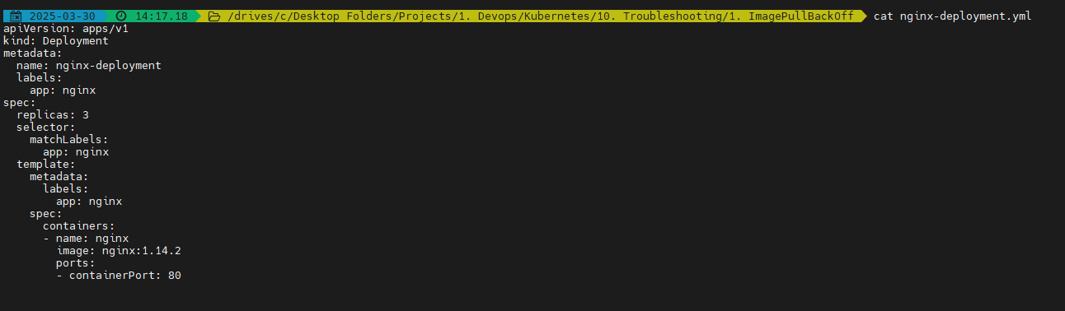

* kubectl apply -n troubleshooting -f nginx-deployment.yml

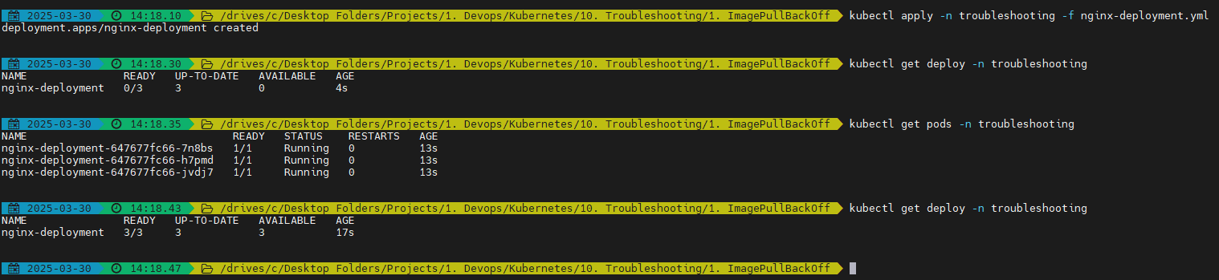

* Delete the deployment



Correct Nginx image:

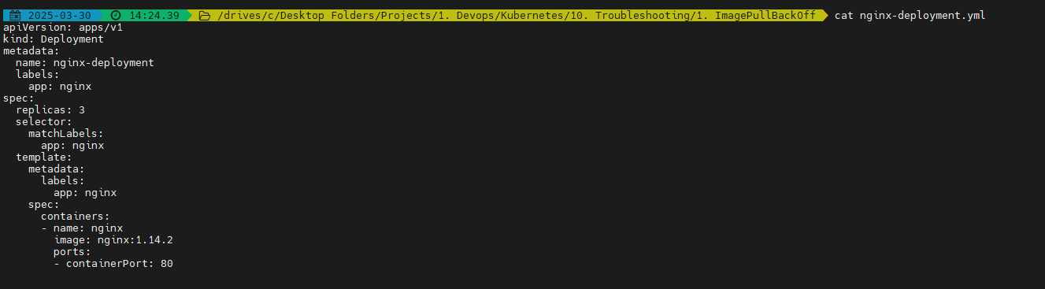

Faulty nginx image:

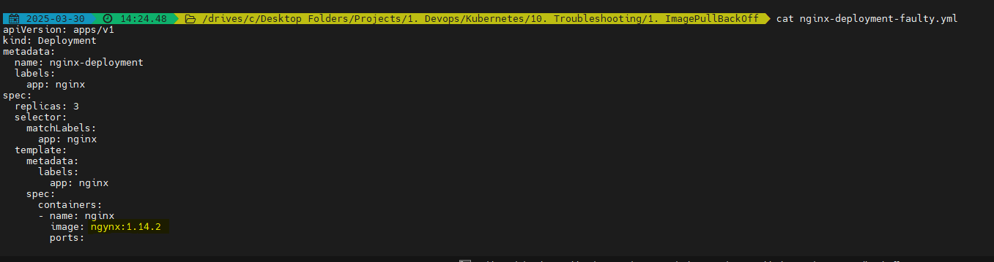

Now you will be able to see:

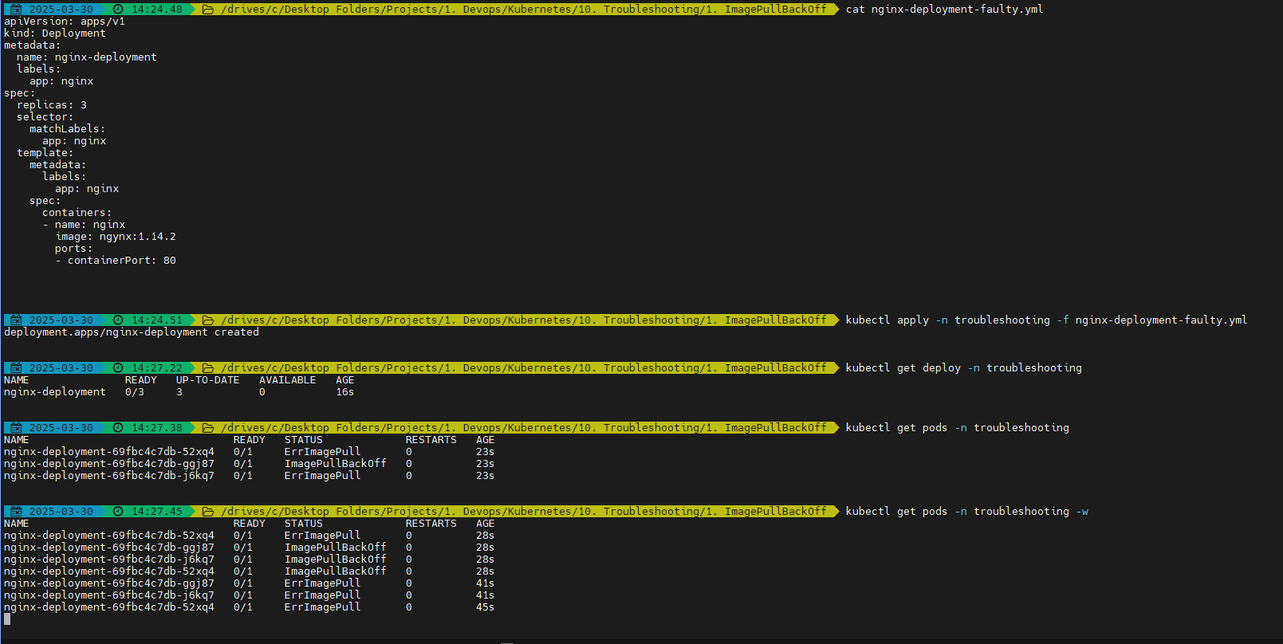

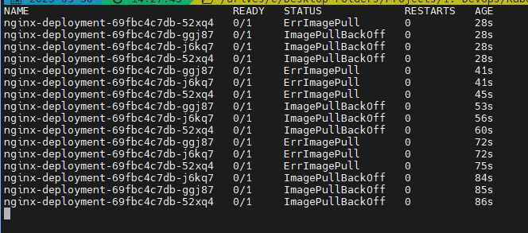

After demo, you can delete the deployment:



**1. Private Docker Registry:**

Pull the image nginx:1.14.2

* docker pull nginx:1.14.2

Now push the image to docker registry:

* docker tag nginx:1.14.2 fzhussain/nginx-private-image-demo:v1
* docker push fzhussain/nginx-private-image-demo:v1



By default this will be public. Hence, make it private

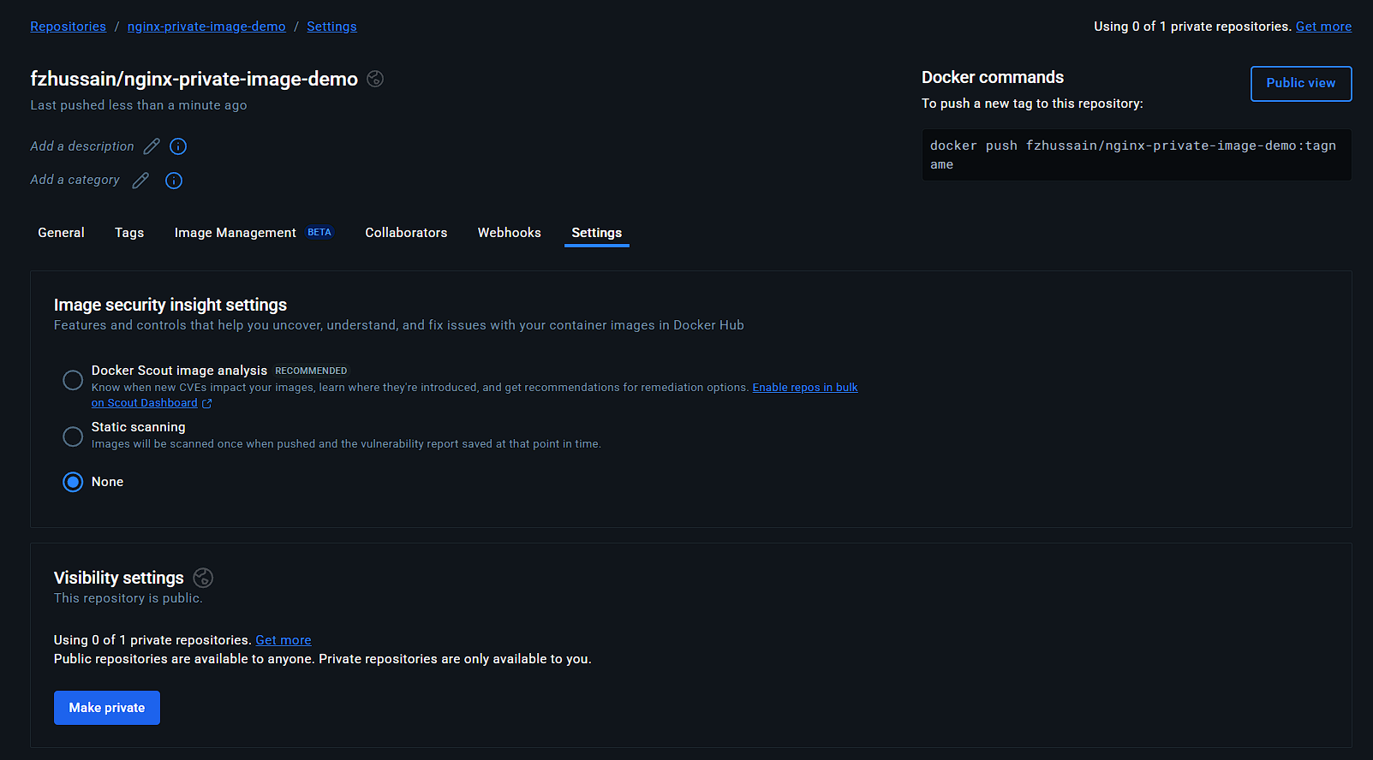



Create your deployment file with the image name:

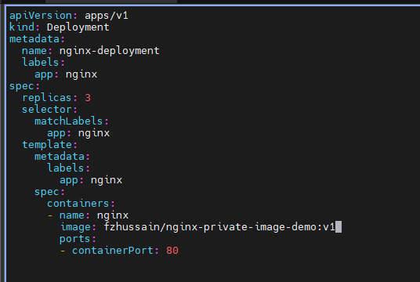

Apply your deployment:

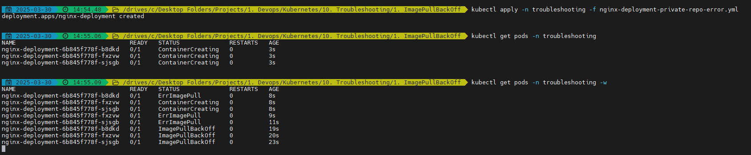

You may get the same error

If you want to solve this error:

You can refer: <https://kubernetes.io/docs/tasks/configure-pod-container/pull-image-private-registry/>

Create a secret using:

kubectl create secret docker-registry faraz-docker-secret -n troubleshooting --docker-server=https://index.docker.io/v1/ --docker-username=fzhussain --docker-password=<your password> --docker-email=<your email>



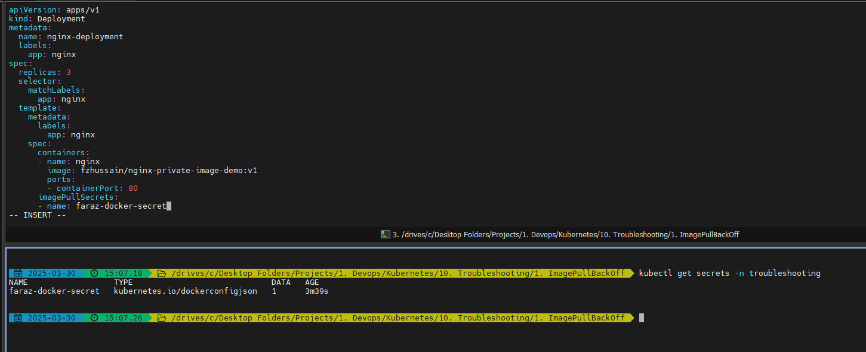

Apply the deployment and test:

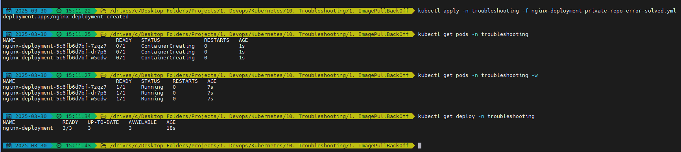

Now you will be able to see that the private docker registry is now accessible.

For secrets creation for AWS ECR: <https://docs.aws.amazon.com/AmazonECR/latest/userguide/docker-pull-ecr-image.html>